Type GLY-A

Ultraviolet Ray Therapeutic Apparatus

Operating Instruction Manual

Langfang Haomai Medical Instrument Co., Ltd

Add: No. 9 Cailiu Road, Jiuzhou Town, Guangyang District of Langfang City
“License for Medical Instrument Manufacturers”NO. 20150011
“License for Medical Instrument Registration”NO. 20152260080
“Product Technical Requirements”NO. 20152260080
Tel: 0316-8095912 0316-2291268 18831612498
Postcode: 065000
Revision date of this specification：Dec 20，2014
Production date: See tag of Medical Instrument
Service life of product: 5 years
Dear users:
How do you do!Welcome to choose the product of Langfang Haomai Medical Instrument Co., Ltd. In order to ensure your correct use of this product and give full play to its due role,please read the instructions of detailed content before use. If there are issues, please contact with our company, you can also consult relevant professional doctor.
Service phone number: 18831612498 0316-8095912
Thank you for your cooperation!
Summary:
Type GLY-A ultraviolet ray therapeutic apparatus is made of host, surface irradiator and body cavity irradiator (the straight and bend derivation of ultraviolet quartz glass).The host control by CPU programming, use the hot cathode ultraviolet ray tube and intelligent control circuit, can be preseted for treatment mode, treatment time and so on.
【Product structure and component diagram】
The front panel of type GLY-A ultraviolet ray therapeutic apparatus
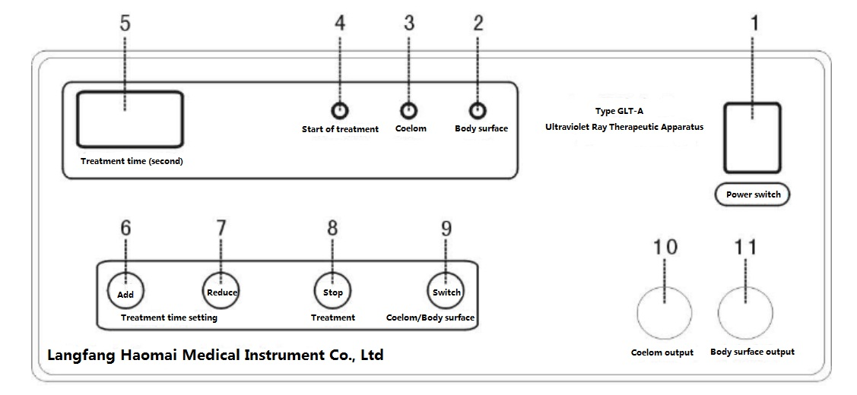
The back panel of type GLY-A ultraviolet ray therapeutic apparatus
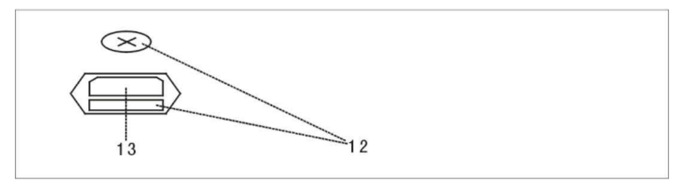
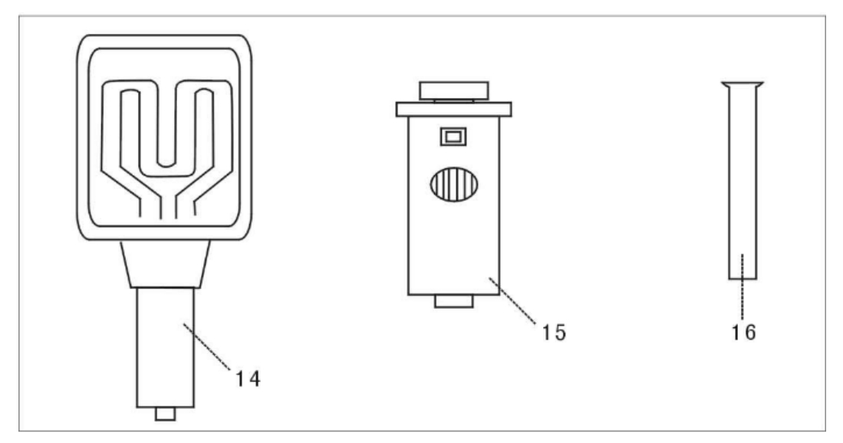
1、Power switch 2、Surface light 3、Coelomic cavity light 4、Treatment light 5、Treatment time show 6、Treatment time add 7、Treatment time reduce 8、Treatment stop 9、Coelom/body surface switch 10、Coelom output 11、Body surface output 12、protective tube 13、 Power supply socket 14、Body surface irradiator 15、Coelom irradiator 16、Derivation
【The main function】
Diminish inflammation, detumescence, analgesia and promote tissue regeneration
【Scope of application】
Postoperative wound, trauma infection, bedsore and tonsillitis
【Operation method】
1、Turn on the power supply, connect the coelom and body surface irradiation device with the output line, insert the other end of the instrument in the socket;
2、Open the power switch, treatment time according to the initial time of 10 seconds, at the same time the light of body cavity irradiator is onlight (body surface treatment press the body cavity/body surface conversion button, the light of body surface irradiator is onlight);
3、Press the time set to increase or reduce the necessary treatment time;
4、When the Body cavity treatment , unscrew the body cavity irradiator guide card head, choose the derivation according to necessary, insert it gently until touch the inner tube and spin the head, then wait to use (when inserting the derivation, you must be gently, in order to avoid the tube burst);
5、Preheating tube after 30 seconds, press the switch key choose the body cavity or body surface treatment, press the micro switch on the body cavity or body surface irradiator handle, the light of treatment indicator is onlight and the tube enter the working state, the treatment is started;
6、When the treatment time over, instrument buzzer prompt the irradiation is finished, the tube back to prepare status, the light of treatment is extinguished, timer display in the selected initial status, shut off the power switch, the treatment is ended.
7、Period of treatment: see attachment“Reference Table of Ultraviolet Irradiation Dose”

【Matters needing attention】
- The instrument must be used by professionals, read the instructions before use; retest the tube biometric once every half a year.
- Wipe gently the tube and derivation with 95% alcohol cotton ball before using;
- When body surface irradiation therapy, the hole towel or cut hole paper shoud cover the non-treatment area, the distance between Irradiation area from the tube is advisable to 3 cm;
- Body cavity treatment should close up Irradiation, light guide should take and put down gently, make sure that it is clean after using, immerse it in 75% alcohol disinfection to wait using;
- After irradiator alignment parts of treatment, start the treatment timer switch on the handle, after buzzer prompt the treatment end, you need to immediately remove the irradiator, in order to reduce the irradiation time of non-treatment;
- Do not looking directly at light of working Ultraviolet tube, the operator must wear protective goggles;
- After the treatment, you need to turn off the power supply in time; It is not for a long time in the standby status;
- Instrument must be good grounding, must pull the power plug before replacing insurance tube;
- After opening the power switch, plugging and pulling out body cavity or body surface irradiation device is forbidden;
- You should avoid pushing and pulling output line, in order to prevent the damage;
- Please using under the guidance of doctor;
- If you have any discomfort, you should stop treatment immediately.
【Contraindications】
Heart failure, myocarditis, nephritis, uremia, active tuberculosis, lupus erythematosus, solar dermatitis, porphyrin metabolic disorders, dry skin pigmentation, poisoning associated with fever, rash of infectious diseases, acute tumor local, internal and external use photosensitive drugs.
【The main technical indicators】
- The main wavelength of ultraviolet: 254 nm;
- Intensity of ultraviolet radiation: body cavity irradiator intensity (straight derivation close up illuminate) ≥10mW/cm², bend derivation close up illuminate ≥5mW/cm²; Strength of body surface irradiator ≥10 mW/cm²;
- Power: ≤60VA
- Treatment timing range: 1~999 seconds (step adjustable);
- Safety type: type I type B applied part;
- Fuse: 5 x20BX 1 A (two)；
- Conditions of use:
Environmental temperature: 5 ℃ ~ 40 ℃
Relative humidity: ≤85%
Power supply: 220V±22V 50Hz±1Hz
【Maintenance】
1、The instrument should be electricity once half year for a long time nonuse.
2、The instrument warranty for one year.
3、Without company's authorization, users do not open the case.
【Standard configuration listing】
- One therapeutic host .
- One power line.
- Two output line.
- One body surface irradiation device, one body cavity irradiator device.
- One straight derivation of ultraviolet quartz glass. One bend derivation of ultraviolet quartz glass.
- One portable box.
【Transportation and storage】
1、Transportation: packed therapeutic apparatus should be handled with great care in the process of transportation, general transport can be used, shock, moisture and pressure defense.
2、Storage: packed therapeutic apparatus should be storage in the environment that temperature is between -20℃ ~ +55℃, relative humidity ≤90%, no corrosive gas and ventilated.
【Instrument, manual symbol】
！ --Output jack, pay attention to safety.
- --Type B applied part.

